Bloom’s Taxonomy
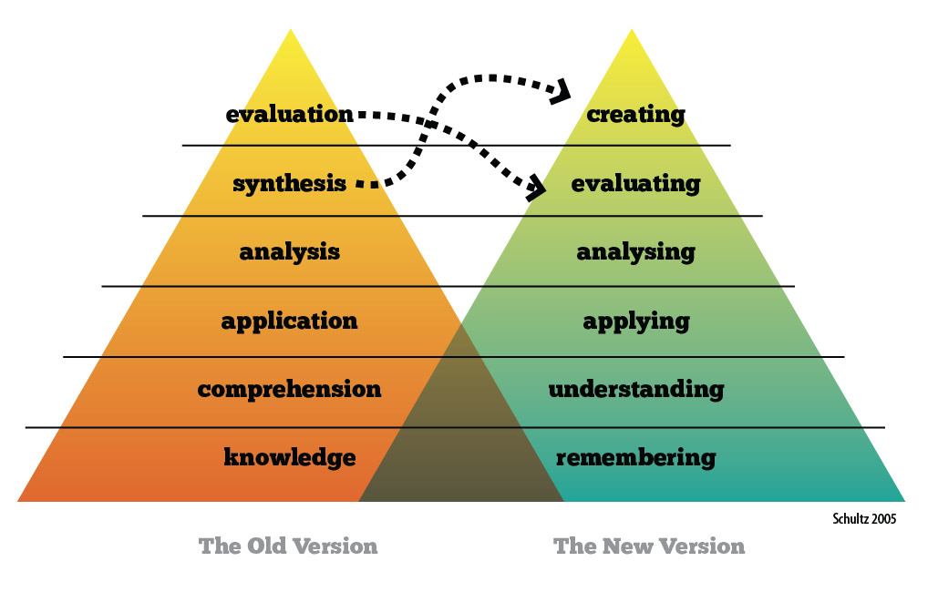

Bloom’s Taxonomy classifies objectives that educators set for students, what are known as LEARNING OBJECTIVES.
LEARNING OBJECTIVES are WHAT YOU WANT THE STUDENT TO KNOW or BE ABLE TO DO at the end of a lesson.
LEARNING OBJECTIVES are described in ACTIVE VERBS
